**--1 What is the total qty of Ground Nut purchased in 2019?**

select sum(qty_in_quintal) as total_qty from purchase where commodity= 'Ground Nut' and extract(year from invoice_date)=2019;

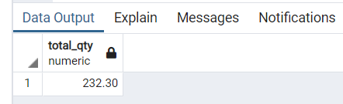

**--2 what is the total qty of commodities purchased in 2019?**

select commodity, sum(qty_in_quintal) as total_qty from purchase where extract(year from invoice_date)=2019 group by commodity;

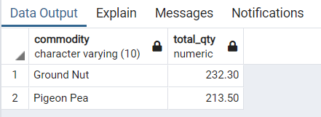

**--3. What is the Total Qty of commodity purchased by each district?**

select district,commodity,sum(qty_in_quintal) as total_qty from farmers as f join purchase as p on f.farmer_id=p.farmer_id group by district,commodity order by total_qty asc;

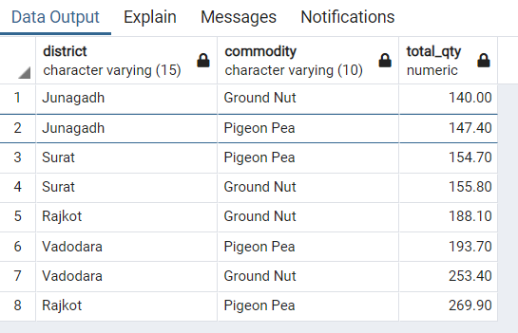

**--4. What is the avg income of the five highest earning farmers?**

select f.farmer_id,farmer_name, avg(payable_amt) as Avg_income from farmers as f join purchase as p on f.farmer_id=p.farmer_id group by f.farmer_id order by Avg_income desc limit 5;

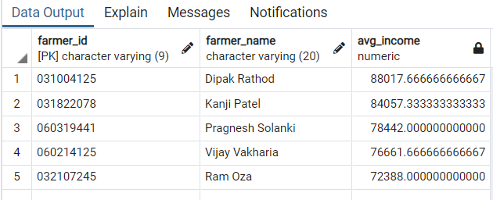

**--5. List the farmers having land area more than five acre.**

select * from (select farmer_name, UID, sum(land_area_in_acre) as Total_area from farmers group by UID,farmer_name) as T where Total_area>5;

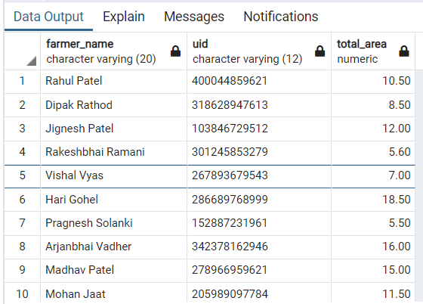

**--6. How many Farmers are getting benefitted from SCSCL?**

select commodity, count(farmer_id) from (select distinct farmer_id,commodity from Purchase) as A group by commodity;

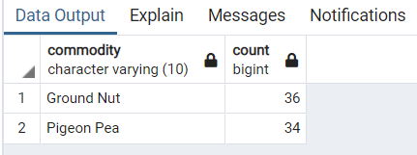

**--7. List the farmers having land in Rajkot.**

select Farmer_id,farmer_name,district from farmers where district = 'Rajkot';

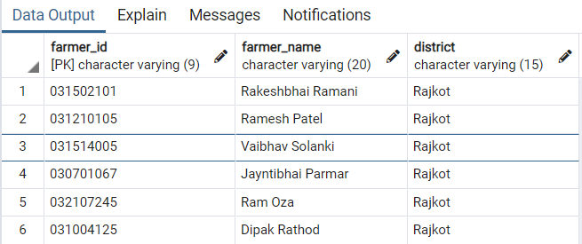

**--8. List the farmers selling Ground Nut between 25-oct-2020 and 25- oct-2021.**

select f.farmer_id,farmer_name from farmers as f join purchase as p on f.farmer_id=p.farmer_id where invoice_date between '2020-10-25' and '2021-10-25' and commodity='Ground Nut';

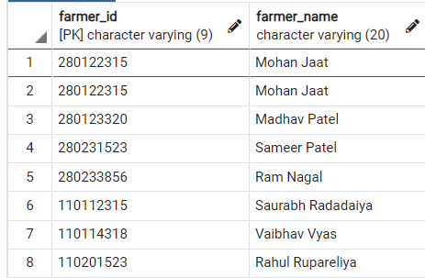

**--9. How much quantity of Pigeon Pea was purchased from a farmer in the kharif season of all years?**

select farmer_id,sum(qty_in_quintal) from purchase where commodity = 'Pigeon Pea' group by farmer_id;

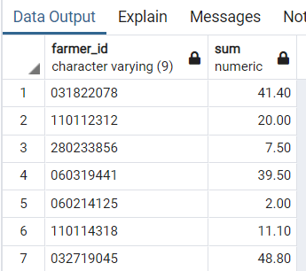

**--10. What is total qty of Ground Nut purchased in all years?**

select sum(qty_in_quintal) from purchase where commodity = 'Ground Nut';

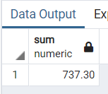

**--11. What is the total quantity of each commodity that every center got in 2021?**

select center_id, commodity, sum(qty_in_quintal) FROM purchase where extract(year from invoice_date)=2021 group by center_id , commodity order by center_id;

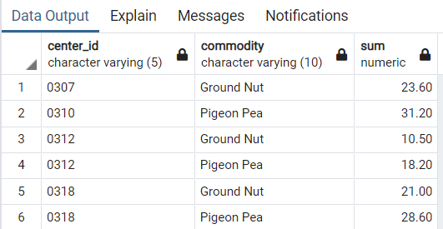

**--12. List the shops in Junagadh district.**

select shop_name,shop_id from shop where district = 'Junagadh';

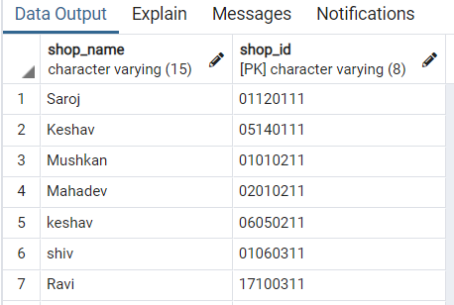

**--13. What is the total quantity of commodities transferred to the shops in ‘Vanthali’ taluka between 25th October 2020 and 25th October 2021?**

select s.shop_id,shop_name,sum(qty_in_quintal) from shop as s join shop_transport as t on s.shop_id=t.shop_id where taluka ='Vanthali' and tp_date between '2020-10-25' and '2021-10-25' group by s.shop_id, shop_name;

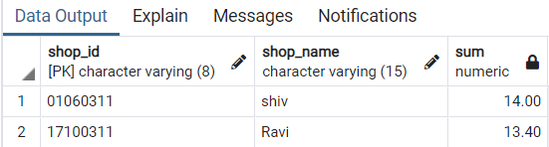

**--14. List the farmers who do not sell their commodities to SCSCL.**

select distinct farmer_id from farmers group by farmer_id except (select distinct farmer_id from purchase group by farmer_id );

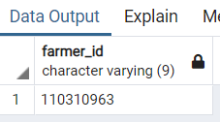

**--15. What are the total number of registrations on uid = '401212347894'?**

select count(farmer_id) as No_of_registration from farmers where uid='401212347894';

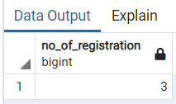

**--16. Details of employees working at Olpad-2 center.**

select employee_id,employee_name,center_name,manager_id,taluka from employee as e join center as c on e.center_id=c.center_id where center_name='Olpad-2';

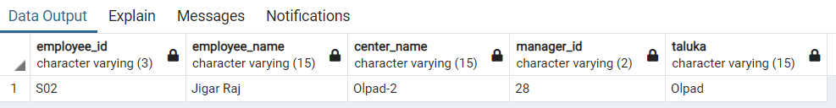

**--17. Which warehouses are managed by Raj Sharma?** select * from warehouse as w join manager as m on

w.manager_id=m.manager_id where manager_name='Raj Sharma';

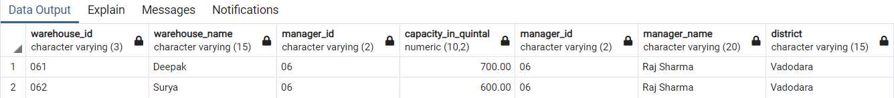

**--18. list of employees managed by all the managers.**

select employee_id,employee_name from

(select center_id,manager_id from center union select warehouse_id,manager_id from warehouse)

as M join

(select center_id,employee_id,employee_name from employee union select warehouse_id,employee_id,employee_name from employee)

as E on M.center_id = E.center_id where manager_id = '11';

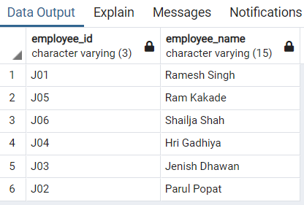

**--19. What was the total quantity of commodity that a shop having ID 01041003 got in all the years?**

select s.shop_id,s.shop_name,st.commodity,sum(qty_in_quintal) as total_quntity from shop as s join shop_transport as st on s.shop_id=st.shop_id where s.shop_id='01041003' group by(s.shop_id,st.commodity);

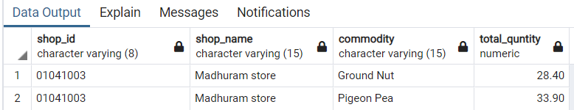

**--20. List the stock availability on every date in the warehouse having id 281.**

select warehouse_id, date, commodity, stock_in_quintal from stocks where warehouse_id='281' and extract(year from date)=2019;

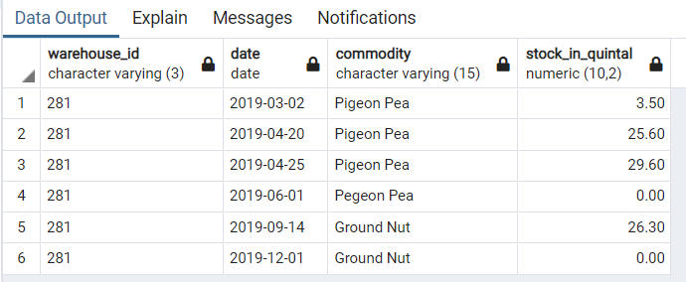

**--21. What is the stock on 05-May-2019?**

select warehouse_id, commodity, stock_in_quintal from stocks where warehouse_id='281' and date<='2019-05-05' order by date desc limit 1;

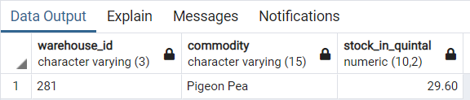

**--22. What is the total amount that SCSCL paid to all the farmers every year?**

select extract(year from invoice_date) as year, sum(payable_amt) as Amount_paid from purchase group by extract(year from invoice_date) order by year;

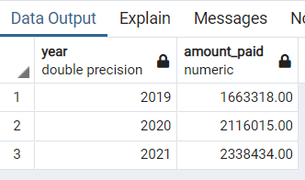

**--23. What is the total quantity of Ground Nut or Pigeon Pea purchased from a farmers?**

select commodity , sum(qty_in_quintal) as total_purchase from purchase group by commodity;

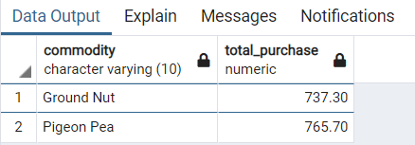

**--24. List the farmers who sell Pigeon Pea but not Ground Nut.**

select farmer_id from purchase where commodity = 'Pigeon Pea' except

select farmer_id from purchase where commodity = 'Ground Nut';

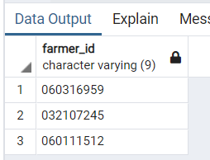

**--25. Farmer having id 110112315 transported his commodity to which warehouse?**

select farmer_id,invoice_date,warehouse_id,P.commodity

from purchase as P join wh_transport as W on P.invoice_no = W.invoice_no where farmer_id = '110112315';

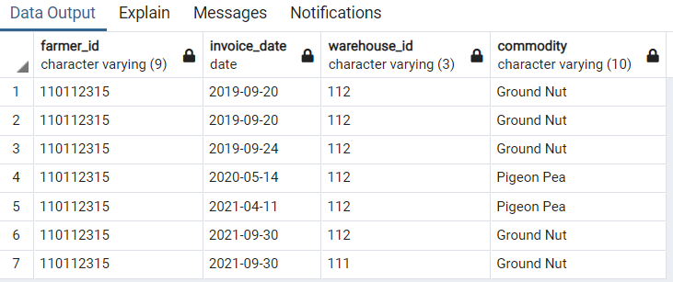

**--26. List the farmers whose commodities got transported to a warehouse having id 281.**

select distinct f.farmer_id,farmer_name from farmers as f join purchase as p on f.farmer_id=p.farmer_id join wh_transport as wt on p.invoice_no=wt.invoice_no where warehouse_id='281';

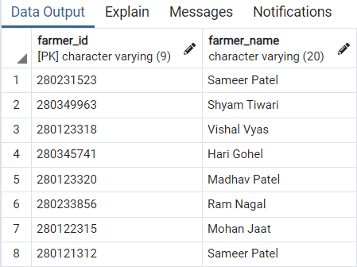

**--27. List the farmers who got paid more than 50,000 in 2020**.

select f.farmer_id,f.farmer_name,payable_amt from farmers as f join

purchase as p on f.farmer_id=p.farmer_id where payable_amt>50000 and extract(year from invoice_date)='2020';

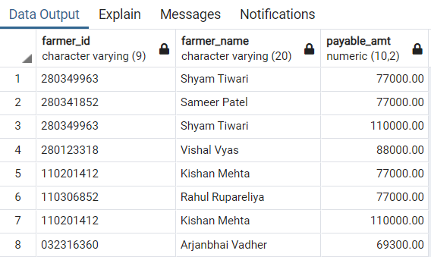

**--28. Display the date and warehouse on which the stock of Pigeon Pea becomes zero.**

select s.warehouse_id,w.warehouse_name,date from stocks as s join warehouse as w on s.warehouse_id=w.warehouse_id where stock_in_quintal=0 and commodity='Pigeon Pea';

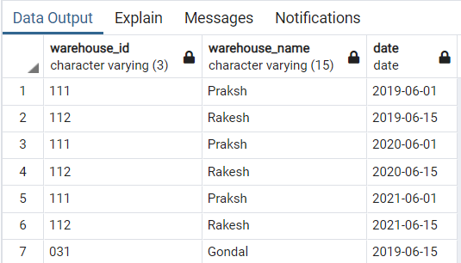

**--29. List the centers who have purchased commodities less than 51 quintal.**

select c.center_id,center_name,qty_in_quintal,invoice_date from purchase as p join center as c on p.center_id=c.center_id where commodity='Ground Nut' and season='Kharif' and qty_in_quintal<50;

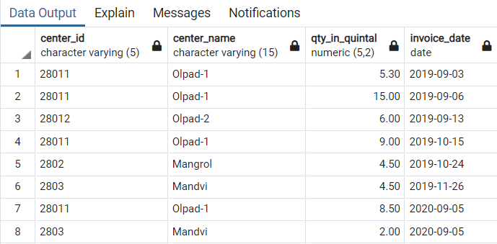

**--30. Which warehouse had maximum quantity of Pigeon Pea in 2019?**

select s.warehouse_id,w.warehouse_name,sum(s.in_qty_in_quintal) as total_qty from warehouse as w join stocks as s on w.warehouse_id=s.warehouse_id where commodity='Pigeon Pea' and extract(year from s.date)='2019' group by (s.warehouse_id,w.warehouse_name) order by (total_qty) desc limit 1;

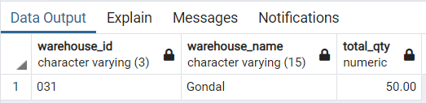

**--31. Which warehouse had minimum quantity of Ground Nut in 2020?**

select s.warehouse_id,w.warehouse_name,sum(s.in_qty_in_quintal) as total_qty from warehouse as w join stocks as s on w.warehouse_id=s.warehouse_id where commodity='Ground Nut' and extract(year from s.date)='2020' group by (s.warehouse_id,w.warehouse_name) order by (total_qty) asc limit 1;

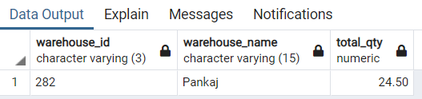

**--32. What is the average production of Ground Nut Per acre?**

select district,(sum(qty_in_quintal)/sum(land_area_in_acre)) as avg_production_per_acre from farmers as f join purchase as p on f.farmer_id=p.farmer_id where commodity='Ground Nut' group by (district);

